Multiple-choice section

|  |  |  |  |  |  |  |  |  |  |  |  |  |  |
| --- | --- | --- | --- | --- | --- | --- | --- | --- | --- | --- | --- | --- | --- |
| Question | 1 | 2 | 3 | 4 | 5 | 6 | 7 | 8 | 9 | 10 | 11 | 12 | 13 |
| Answer | A | D | D | B | A | B | C | B | D | B | D | C | B |

|  |  |  |  |  |  |  |  |  |  |  |  |  |
| --- | --- | --- | --- | --- | --- | --- | --- | --- | --- | --- | --- | --- |
| Question | 14 | 15 | 16 | 17 | 18 | 19 | 20 | 21 | 22 | 23 | 24 | 25 |
| Answer | A | C | D | C | A | A | D | B | A | B | D | A |

Question 1 [1.4]

A

Amount earned over $6000   
= $(28 500 – 6000)

= $22 500

Tax payable on $22 500   
= 0.15 × 22 500

= $3375

Question 2 [1.5]

D

*I* = *PrT*

*P* = 

*P* = 

*P* = $228.86

*P* ≈ $229

Question 3 [2.1]

D

Using Pythagoras’ theorem:

*a*2 + *b*2= 42 + 9.62

= 108.16

≠ 102

*a*2 + *b*2= 42 + 4.32

= 34.49

≠ 5.92

*a*2 + *b*2 = 42 + 52

= 41

≠ 62

*a*2 + *b*2 = 42 + 7.52

= 72.25

= 8.52

Question 4 [2.3]

B

Using Pythagoras’ theorem:

*b*2 = *c*2 –*a*2

= 14.642 – 9.722

= 119.8512

*b* = 10.947 657 28

= 10.95 (2 d.p.)

Question 5 [2.4]

A

Using Pythagoras’ theorem:

*c*= 

Length of closed path

=

= 

= 308.058 436

= 308 m (to the nearest metre)

Distance on footpath

= 250 + 180

= 430 m

Extra distance = 430 – 308

= 122 m

Question 6 [3.3]

B

0.023 45 × 0.04 = 0.001 078 7

= 

= 1.0787 × 10-3

Question 7 [3.6]

C

(6*d* + 5)(6*d* – 5) – (4*d* + 3)(4*d* – 3)

= 36*d*2 – 25 – (16*d*2 – 9)

= 36*d*2 – 25 – 16*d*2 + 9

= 20*d*2 – 16

Question 8 [4.2]

B

*r* = 

= 

= 6.73

Area of circle = π*r*2

= π × 6.732

= 142.918 419

≈ 142.29 cm2

Question 9 [4.3]

D

Surface area of a rectangular prism   
= 2(*lw +lh + wh*)

= 2 × (3.26 × 4.67 + 3.26 × 1.39 + 4.67 × 1.39)

= 2× 26.2469

= 52.4938

≈ 52.49 cm2

Question 10 [4.4]

B

volume = area of cross section × *H*

= area of trapezium *× H*

=**

= **

=600 m3

capacity = 600 kL

Question 11 [5.1]

D

5 – 2*r* = -1

5 – 5 – 2*r* = -1 – 5

-2*r* = -6



*r* = 3

Question 12 [5.2]

C

*p* = 2*rx* – *q*

*2rx* = *p + q*

*x* = 

correct

*2rx* = *p + q*

*r* = 

correct

*x* = 

incorrect

*q = 2rx* – *p*

correct

Question 13 [5.5]

B

3*y* + 4*x* = -6

3*y* = -4*x* – 6

*y* = 

*y* = 

*y* = *mx* + *b*

*m* = 

Question 14 [5.6]

A

5*y* = 2*x* – 10

Where *x* = 0:

5*y* = -10

*y* = -2

(0, -2)

Where *y* = 0:

0 = 2*x* – 10

2*x* = 10

*x* = 5

(5, 0)

Question 15 [6.3]

C

A square is a rectangle with all sides equal—true

A rhombus is a kite with all sides equal—true

A rectangle is not a kite—false

A square is a rhombus with a right angle—true

Question 16 [6.6]

D

As the triangles are similar,

****

Rearranging,

****

Question 17 [6.7]

C

The net in **C** would have two squares on top of each other and one face would be missing.

Question 18 [7.2]

A

In a right-angled triangle, if one angle is 34°, the third angle must be 56° (180 – 90 – 34 =56).

The side adjacent to 34° is the side opposite 56°.

sin(θ) = ,cos(θ) = ****

cos(34°) = sin(56°)

Question 19 [7.3]

A

sin(θ) = 

sin(50°) = 

*m* =

Question 20 [8.2]

D

People selected at a supermarket may not all be eligible to vote and may not be indicative of the population due to socio-economic factors.

People selected at a football match may not all be eligible to vote and may not be indicative of the population, especially if issues related to sport might affect their voting intentions.

People who do not have a listed phone number would not be sampled if a phonebook is used for sampling and people selected at a supermarket or football match may not all be eligible to vote.

Randomly sampling from the electoral roll is the best method to ensure that only eligible voters are surveyed and that there is no bias.

Question 21 [8.6]

B

|  |  |
| --- | --- |
| PM2e_09_EB_eoyes_01 | 8 only play tennis  Pr = = |

Question 22 [9.1]

A

*y* = *x*2 – 8*x* – 9 is the only relationship in which the highest power of the independent variable *x* is 2 and the highest power of the dependent variable *y* is 1.

Question 23 [9.4]

B

(*x* – *h*)2 + (*y* – *k)*2 = *r*2

(*x* + 4)2 + (*y* – 7)2 = 64

*h* = -4, *k* = 7 *r* = 8

centre (*h*, *k*), radius *r* = ( -4, 7), 8

Question 24 [9.5]

D

*y* = 2*x* – *h*+ *k*

*y* = 2*x*

A shift to the left of 8 (*h* = -8)

y = 2*x* + 8

A shift down of 8 (*k* = -7)

*y* = 2*x* + 8 – 7

Question 25 [9.7]

A

Direct proportion can be shown with a symbol

*Vt*

Multiple-choice total marks: 25

Short answer section

Question 26 4 marks [1.1]

**(a)** increased % = 116.3%

increased amount = 

= $5031.14

**(b)** decreased % = (100 – 2.58)%

= 97.42%

decreased amount = 

= $3.88 per kilo

total earnings = $274.77

Question 27 4 marks [2.2]

*x*2 = 34.22 + 29.42

= 2034

**(a)** *x* =cm

**(b)** 45.10 cm

Question 28 3 marks [3.1]

(*x*2*y*)5 × *x*6*y* = *x*10*y*5 ×*x*6*y*

= *x*10 + 6 *y*5 + 1

= *x*16*y*6

Question 29 6 marks [3.2]

 = 

= **

= **

= 

= 

= 

Question 30 6 marks [3.4]

 = 

*c*(*ax* – *ab*) = *b*(*cx* – *b*)

*cax* – *cab* = *bcx* – *b*2

*acx* – *bcx* = *abc* – *b*2

*cx*(*a* – *b*) = *b*(*ac* – *b*)

*x* = **

Question 31 4 marks [3.5]

|  |  |
| --- | --- |
| **(a)** (*c* – 8)(*c* – 6)  = *c*2 – 6*c* – 8*c* + 48  = *c*2 – 14*c* + 48 | **(b)** (2*m* + 4)(3*m* – 7)  = 6*m*2 – 14*m* + 12*m* – 28  = 6*m*2 – 2*m* – 28 |

Question 32 4 marks [3.6]

|  |  |
| --- | --- |
| **(a)** (2*a* + *b*)2  = (2*a*)2 + 2 × 2*a* × *b* + *b*2  = 4*a*2 + 4*ab* + *b*2 | **(b)** (*x* – 3*y*)2  = *x*2 – 2 × *x* × 3*y* + (3*y*)2  = *x*2 – 6*xy* + 9*y*2 |

Question 33 3 marks [3.6]

|  |  |
| --- | --- |
| **(a)** (*m* – *n*)(*m* + *n*) = *m*2 – *n*2 | **(b)** (6*p* + 7*r*)(6*p* – 7*r*)  = (6*p*)2 – (7*r*)2  = 36*p*2 – 49*r*2 |

Question 34 2 marks [3.7]

|  |  |
| --- | --- |
| **(a)** 4*p*2 – 4*p* = 4*p*(*p* – 1) | **(b)** -3*c*2*d* – 9*c*3 = -3*c*2(*d* + 3*c*) |

Question 35 2 marks [3.8]

|  |  |
| --- | --- |
| **(a)** *cd* – *bc* + 3*d* – 3*b*  = *c*(*d* – *b*) + 3(*d* – *b*)  = (*d* – *b*)(*c* + 3) | **(b)** *v*2 – 6*v* – 5*v* + 30  = *v*(*v* – 6) – 5(*v* – 6)  = (*v* – 6)(*v* – 5) |

Question 36 4 marks [4.1]

|  |  |
| --- | --- |
| **(a)** *P* = × 2 × π × 8.5 + 17  *P* = 8.5π + 17  *P* = 43.70 cm (2 d.p.) | **(b)** *P* = × 2 × π × 13.2 + 13.2 × 2  *P* = 85.84 cm (2 d.p.) |

Question 37 4 marks [4.2]

Shaded area = area of trapezium – area of triangle

=  – 

= 

= 1600.11 – 387.04

= 1213.07 cm

Question 38 4 marks [4.4]

*V* = area of base × *H*

= × *H*

=  × 36.8

= 5047.488 m3

Question 39 2 marks [5.1]

|  |  |
| --- | --- |
| **(a)** 4*x* – 7 = 5 – 2*x*  4*x* + 2*x* – 7 = 5 – 2*x* + 2*x*  6*x* – 7 = 5  6*x* – 7 + 7 = 5 + 7  6*x* = 12  =  *x* = 2  LHS = 4 × 2 – 7  = 8 ­– 7  = 1  RHS = 5 – 2 × 2  = 5 – 4  = 1  LHS = RHS | **(b)**  =  6(2*p* + 1) = 5(5*p* + 9)  12*p* + 6 = 25*p* + 45  12*p* – 25*p* + 6 = 25*p* – 25*p* + 45  13*p* + 6 = 45  -13*p* + 6 – 6 = 45 – 6  -13*p* = 39  *p* = -3  LHS =  =  = -1  RHS =  =  =  = -1  LHS = RHS |

Question 40 5 marks [5.3]

*D* = 

= 

= 

= 

= 

= 10

Question 41 5 marks [5.3]

|  |  |  |  |  |  |  |  |
| --- | --- | --- | --- | --- | --- | --- | --- |
| *x* | -3 | -2 | -1 | 0 | 1 | 2 | 3 |
| *y* | 10 | 8 | 6 | 4 | 2 | 0 | -2 |

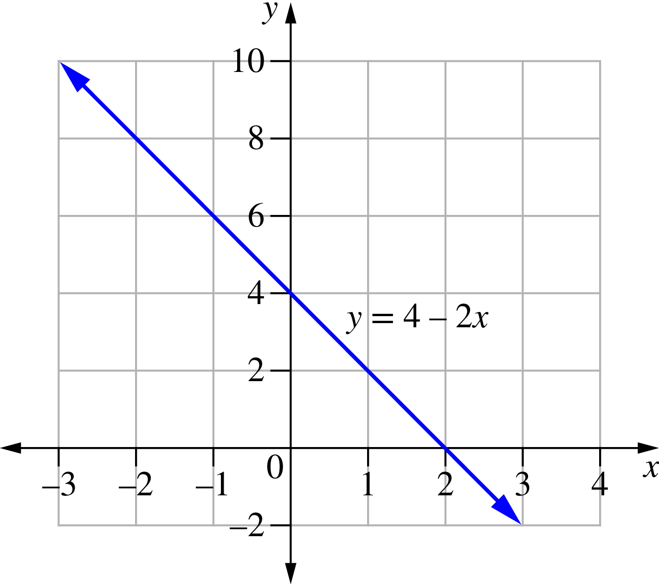

Question 42 3 marks [5.6]

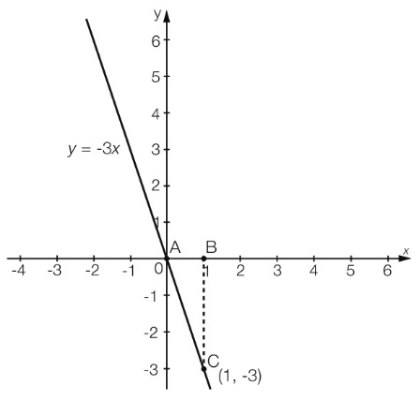

Question 43 3 marks [5.8]

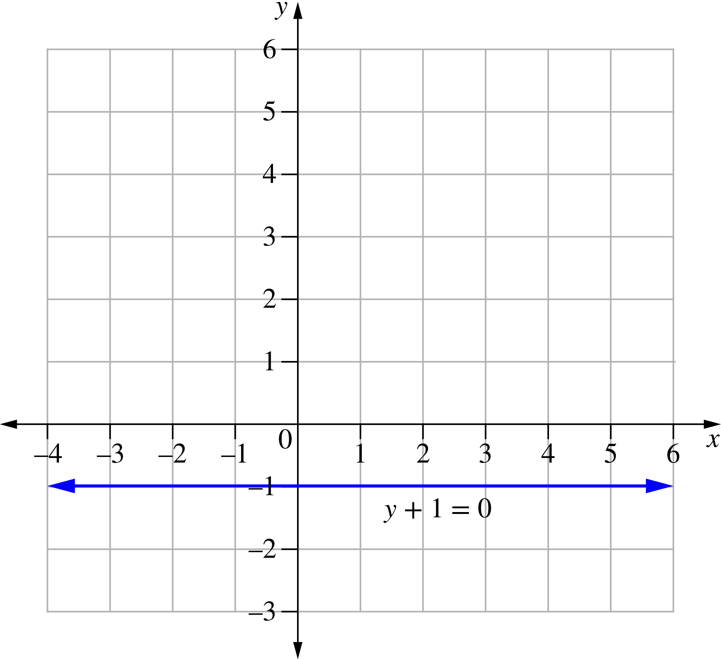

Question 44 4 marks [6.1]

*x* + 72° = 106° (corresponding angles on parallel lines)

(exterior angle of ∆ = sum of interior opposite angles)

*x* *=* 34°

Question 45 2 marks [6.3]

*y* = 90° (diagonals of a rhombus)

Question 46 7 marks [6.6]

∠*PRQ* = ∠*TRS* = (vertically opposite)

∠*PQR* = ∠*TSR* (= 90°)

∠*QPR* = ∠*STR* (alternate angles)

∆*PQR* ≈ ∆*TRS* (AAA)



Question 47 3 marks [7.1]

**(a)** hypotenuse = 16 cm

**(b)** opposite side = 15.5 cm

**(c)** adjacent side = 3.97 cm

Question 48 3 marks [7.3]



Question 49 3 marks [7.4]

cos(θ) = 

θ = cos-1

= 33°

Question 50 6 marks [8.5]

|  |  |  |
| --- | --- | --- |
| **(a)** Pr(6) = | **(b)** Pr(2, 4, 6) = | **(c)** Pr(1, 2, 3,4 ) = |
| **(d)** Pr(4, 5) = = | **(e)** Pr(1, 2) = = | **(f)** Pr(3, 4, 5, 6) =  or 1 – Pr(1, 2) = 1 – = |

Question 51 6 marks [9.2]

|  |  |
| --- | --- |
| **(a)** *x*2*–* 3*x* = 0  *x*(*x* – 3) = 0  *x* = 0 or *x* – 3 = 0  *x* = 0 or *x* = 3 | **(b)** 5*x*2 – 45 = 0  5(*x*2 – 9) = 0  5(*x* – 3)(*x* + 3) = 0  *x* – 3 = 0 or *x* + 3 = 0  *x* = 3 or *x* = -3 |

Question 52 3 marks [9.3]

**(a)** *y =* *x*2 is moved 3 units to the right and 4 units down

**(b)** Turning point is (3, -4).

Question 53 3 marks [9.4]

centre (2, -1), radius = 3

(*x* – 2)2 + (*y* + 1)2 = 9

Question 54 2 marks [9.6]

(a) *k* = 4

|  |  |  |  |  |
| --- | --- | --- | --- | --- |
| *x* | 0 | 3 | 5 | 9 |
| *y* | 0 | 12 | 20 | 36 |

(b) *y* = 4*x*

Short answer total marks: 110

Extended answer section

Question 55 8 marks [1.7]

(a) Cost of first 39 500 L = $1.197 × 39.500 = $47.28

Cost of remainder = 1.37 × 22.787

= $31.22

Total bill = $47.28 + $31.22 + $54.32 + $81.44 + $21.36 + $85.32 = $320.94

(b) Water usage = = 136.89 L/person/day

**(c)** Water cost = $ 78.50

Water cost per person per day = = 17c

Question 56 8 marks [2.4]

Side length of triangle = 7.3 – 3.4 = 3.9 mm

*x*2 = 3.92 + 10.62

= 127.57

*x* = 11.29 mm

*y*2 + 4.72 = *x*2

*y*2 = 127.57 – 22.09

= 105.48

*y* = 10.27 mm

Question 57 14 marks [5.5]

**(a)** *m*AB = *m*BC =  *m*CD = *m*AD =

= = = =

=  =  = = 

= 1 = 0 = 1 undefined

**(b)** *AB* is parallel to *CD*. Therefore the shape is a trapezium.

**(c)** *AD* is vertical because its gradient is undefined.

**(d)** *BC* is horizontal because its gradient is zero.

Question 58 6 marks [8.4]

|  |  |  |
| --- | --- | --- |
| 4 4 3 3 3 3 3 2 2 2 2 2 2 2 1 1 0 0 0 | 0L | 0 1 2 2 2 2 2 3 3 3 3 3 4 4 4 4 4 |
| 9 9 8 8 7 7 6 5 5 5 | 0U | 5 5 5 5 8 8 8 9 9 9 |
| 4 2 2 2 2 | 1L | 0 0 0 4 4 |
| 8 7 5 | 1U | 5 7 8 |
|  | 2L | 1 2 |
|  | 2U | 9 |
| 2 | 3L | 3 |
|  | 3U |  |
| 0 0 | 4L | 0 |

Both samples are positively skewed but the median for the first group is 9 hours, whereas the median for the second group is only 5 hours. The minimum is the same for both groups (0); the maximum is also the same (40).

Question 59 4 marks [9.5]

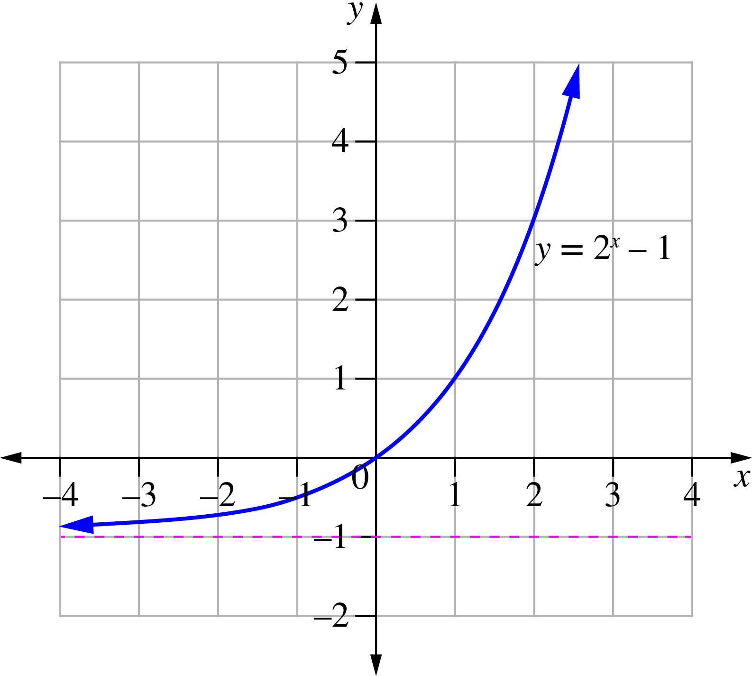

Extended answer total marks: 40

TOTAL test marks: 130